Name ____Key____________

BIO 300/CMPSC 300

Spring 2016

Chapter 3 – N-W Algorithm

1. Use the Needleman-Wunsch algorithm generate all optimal global alignments for the sequences ACGTACT and ACTACGT. Please show your work as demonstrated in class.

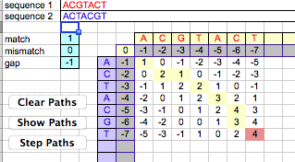

ACGTAC-T

AC-TACGT SCORE OF 4

1. Use the Needleman-Wunsch algorithm generate all optimal global alignments for the sequences CTAG and CGCTAATC. Hint: you should find 10 altogether; the score for each should be -1. Please show your work as demonstrated in class.

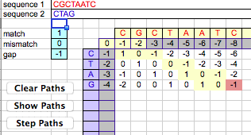

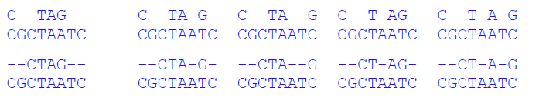

1. When do you expect to happen if you aligned CAG with TTTCAGCAGTTT? Use the Needleman-Wunsch algorithm generate all optimal global alignments for these sequences. Please show your work as demonstrated in class. Were your expectations correct? Why or why not?

One might expect two possible alignments, with CAG aligning either with the first CAT repeat in the longer sequence or with the second one. But this is not the case, because CA---G and C---AG align just as well, at least when the gap penalty is linear. Four optimal alignments, score -6.